

**Colby and Banningham Parish Council**

**Newsletter - October 2024**

**1. Exciting news – a new Playground is coming !**

The survey of residents earlier this year showed great support for the idea of setting up a new children’s play area in the parish. The Parish Council has been working hard putting in bids to funding organisations and has collected costed proposals from a number of established providers of playground equipment with whom we have had considerable negotiations. We also had great support in our bids from the students and staff at Colby School.

So, we were delighted to hear that we have been successful with 2 bids which will provide all the funds we need for this project and we have now agreed a contract with HAGS who have already been able to make a start on installation in the Elden’s Retreat field on Bridge Road. We are also arranging appropriate insurance and safety maintenance for the future.

This is great news! The playground will contain play equipment suitable for children aged 4 to 12 years. It will be fenced off and have seating for adults. Please go and have a look at the progress but make sure that children keep outside the fencing whilst the work is going on. We hope to be able to announce an opening of the new play area some time in November.

**2. Summer event on 17 August 2024**

Over 120 people came along to our first new summer event on Saturday 17 August. Luckily the weather was excellent and we enjoyed live music from Liz Wolfe, a great barbeque done by John Filby and a bar run by David Holgate with beers provided by Jeannie Feneron. There were games, displays and the opportunity to see the progress we have made in our Community Hall. Although we decided to subsidise a drink and something from the barbeque for everyone, we did in the end manage to break even!

A huge thank you to all those many people who helped on the day, to those mentioned above and of course to all of you for coming along and making it such a community success.

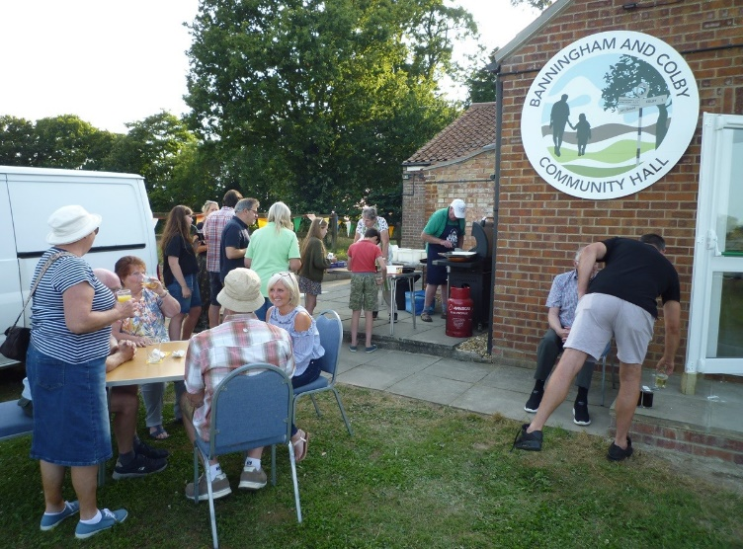 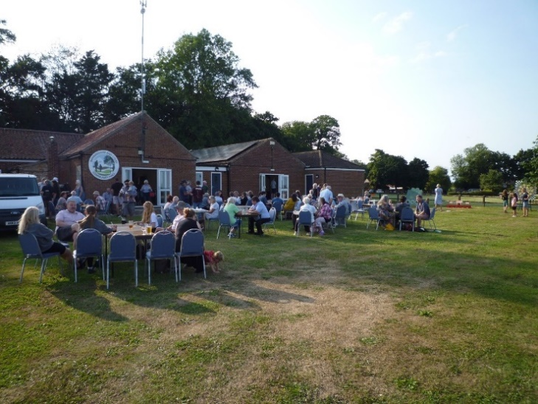

**3. Christmas is coming!**

The next community event will be just before Christmas when we hold the Christmas Lights and Carols on the Green with mince pies and mulled wine. We will let you know the arrangements in December.

**4. Road Closures**

There are a number of planned road closures which will take place over the coming weeks to allow for the work to install the cable for the Norfolk Offshore Wind Zone. RWE and Murphy, the main contractors involved have sent letters to close residents detailing the closures. If you have any questions you are advised to contact Victoria Crawford, Local Liaison Officer for Murphy on 07887 877 816 or E-mail: [victoriacrawford@murphygroup.co.uk](mailto:victoriacrawford@murphygroup.co.uk). Further information is also available at www.nowzone.co.uk.

Anglian Water are also closing Colby Road near to Highbury Farm from 30 October for 3 days.

**5. Thefts in the village**

We have heard of 2 recent thefts which have taken place in the Banningham end of the Parish and would like to remind all residents to secure their property and be vigilant about any unusual behaviour – and report it to the police.

**6. Request for Hessian backed carpet**

The new hedge on the village green is beginning to look good. We would like to suppress the grass growing up between the hedge plants and it has been suggested we could do this at no cost by using hessian backed carpet pieces which can go around the plants. (Rubber or plastic based carpet is not appropriate). If you can help with this please contact Colin Studholme, our clerk – contact details below.

**7. Broadband**

We have chased Openreach about progress with their planned installation of full fibre to premises but have unfortunately been told that there are difficulties and their plans have been shelved. We have registered our unhappiness at this news and our case has now been taken up by our District Councillor, our County Councillor and our MP! In the meantime, the only provision of FTTP is through County Broadband.

**8. Community Hall**

Progress with the renovations is continuing – the former Sandy Lane Club side is now mostly complete and work on extending the old boiler room to be a store room is well under way with the new roof now going on.

We would welcome some volunteers to help on Saturday 2nd November to plant some bulbs around the hall – meet at 10.00 and please bring a trowel. Should be finished by 12.00.

There are now a number of regular events at the hall which are open to residents including:

Mondays at  9.30am   - Bridge. Contact Ann on 07810 513668

Mondays at 2pm - Short mat bowls. Contact Chris on 01692 403339

Tuesdays at 6.30pm - Table tennis.  Contact Jonathan on 01263 478168

Wednesdays at 9.30am - Baby and Toddler group. Contact Sophie on 07490 776500

Wednesdays at 6.00pm - Dog training. Contact Rebecca on 07494 905812

3rd Wednesday of the month at 7.00pm – Parish Council meetings

Fridays (starting 8th November) at 9.00am - Baby and Toddler Group. Contact Sophie on 07490 776500

1st Thursday of the month at 7.00pm - Gardening club. Contact Hazel on 01263 733167

Fridays, once a month - Luncheon club. Contact Jeanie on 07717 110104

Please call David Holgate on 07860 498729 for more information about events in the hall or if you are interested in using it.

As a reminder, there is a website to find out about using our Community Hall - [**https://www.banninghamcommunityhall.co.uk**](https://www.banninghamcommunityhall.co.uk)

**I**f you have any further questions about this newsletter, then please do call the Parish Clerk on 01263 58752 or e-mail [clerk@colby-banningham-pc.gov.uk](mailto:clerk@colby-banningham-pc.gov.uk) .