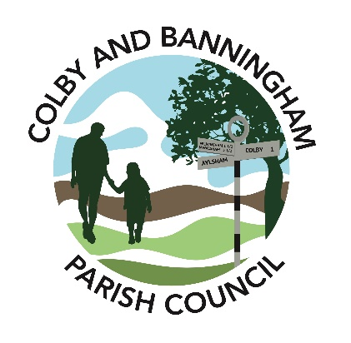

**Parish Council Newsletter - December 2024**

**1. Christmas event on Wednesday 18th December**

This year we will hold another of our popular Christmas event which involves the Christmas lights competition and an evening event of carols on the Village Green with mulled wine and mince pies. There is no need to register your interest – we will send our judges around the Parish on one evening between the 13 and 17 December, so make sure your lights are up and on by then! If you live on the edge of the Parish or are at a secluded position but want to be involved then please do let us know.

An invitation to all in the Parish is then to join us on the Village Green, just across from the Banningham Crown, from 6.30pm on Wednesday 18th December. Mulled wine, soft drinks and mince pies will be available next to a Christmas tree which we will set up. Like last year, we have invited Rev. David Chamberlin to lead some carol singing. The winners of the Lights competition will also be announced. It will also be an opportunity to meet with other people in the Parish - so please do come along.

**2. Project Playground means playtime at Colby and Banningham**

There’s a brilliant new venue for the children of Colby and Banningham to run off their energy! The Parish Council has installed a large playground with a mix of exciting equipment, suitable for children aged 2 to14. The high quality equipment, manufactured by HAGS and installed by Premier Playgrounds, features natural colours to blend in with the lovely surrounds of Elden’s Retreat, a wild field and woodland near Colby School close to the heart of both villages.

The council manged to secure 100% of the cost through grants. A North Norfolk Rural Business and Community project, it is part funded by the UK government through the Rural Prosperity Fund and was supported by North Norfolk District Council and delivered in partnership with Norfolk County Council. 75% came from the Rural Prosperity Fund and the remaining 25% from Awards for All.

‘Project Playground’ was initiated after a survey found that many parishioners wanted to see play provision in the villages. The survey was carried out by the Parish Council, which then looked in to funding the project.

“The work, equipment and landscaping was completed with no cost to the parish,” says councillor Jill Morgan who, with councillors Serena Woolliams, David Holgate and Seamus Elliott, made up the subcommittee applying for grants. “It’s a brilliant resource for the villages. The equipment is a wonderful play facility, with some quite challenging designs for the adventurous! At the same time the parents and carers are catered for, with lots of room as well as seating and picnic provision, so they can chat comfortably while looking after their youngsters.”

David adds, “A huge thankyou to local farmer Bruce van Poortvliet, who helped with the groundworks required before the project began. We’re also very grateful to HAGS and Premier Playgrounds, who were able to accommodate some late change to the plans and still completed the project on time and on budget. Plus, of course, thanks to the team at North Norfolk District Council and Awards for All who made it all possible.”

Parish Council chair Richard Anderson Dungar says, “Much work had been done by the Parish Council to engage residents through the parish questionnaire, and the results showed the demand for a new play area. We are delighted that our project subcommittee were able to source grant funding to pay for the whole project. We plan to have an official opening event when the weather improves!”

The playground features equipment such as climbing frames and suspended walkways, balancing beams, slides and roundabouts. A variety of swings include ones for the less abled. The playground is enclosed by fencing to protect children and keep out dogs and other animals.

We hope that you and your families have a good Christmas - but if you have any further questions, then please do call the Parish Clerk on 07756 287290 or e-mail [clerk@colby-banningham-pc.gov.uk](mailto:clerk@colby-banningham-pc.gov.uk) .